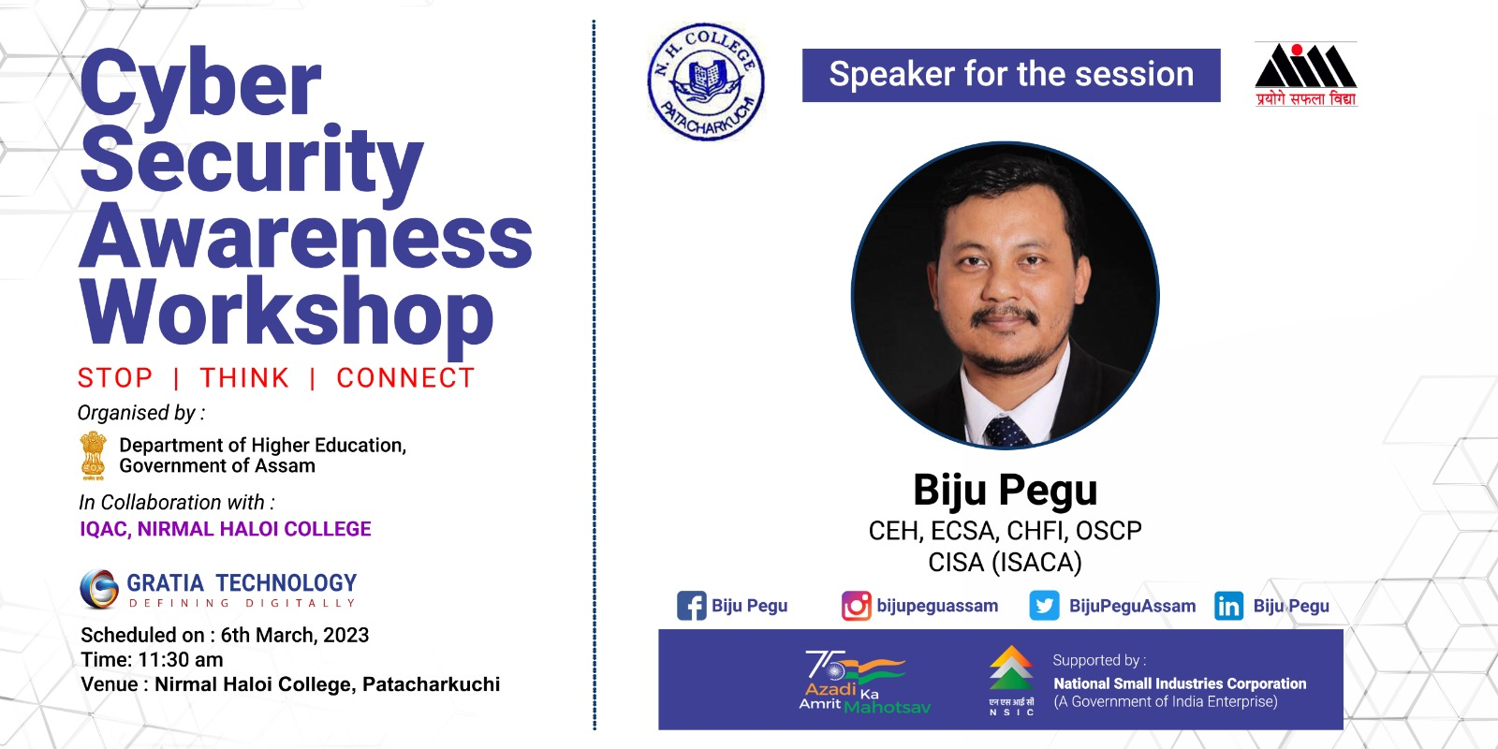
A one day programme on Cyber Security Awareness Workshop Organized by Department of Higher Education, Govt. of Assam will be held on 6th March, 2023 in collaboration with IQAC, N.H. College.

